https://www.digitalocean.com/

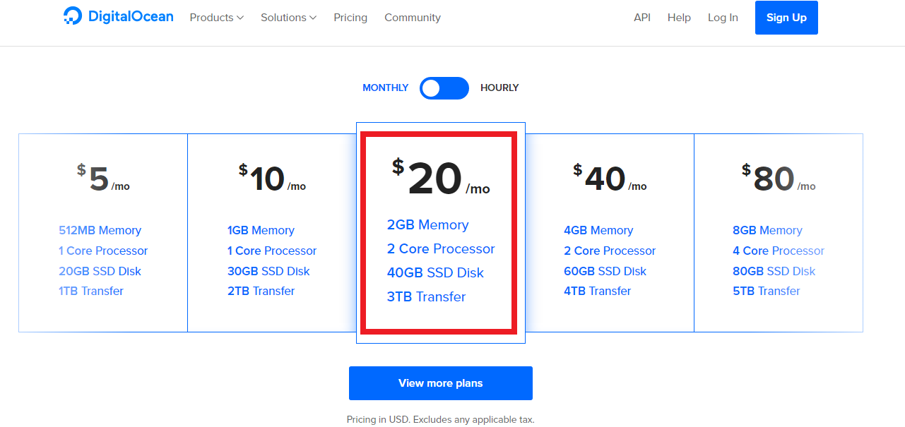

OS Type: Ubuntu 16.04 * 64
Droplet Size: $20/mon: 2G/2CPUs/40GHDD
Droplet Region: US
Additional Option: Default

